**DAILY ONLINE ACTIVITIES SUMMARY**

|  |  |  |  |  |  |  |  |  |
| --- | --- | --- | --- | --- | --- | --- | --- | --- |
| **Date:** | **16/07/2020** | | | | | **Name:** | **POOJA D S** | |
| **Sem & Sec** | **IV Sem & B section** | | | | | **USN:** | **4AL18CS056** | |
| **Online Test Summary** | | | | | | | | |
| **Subject** | | **-** | | | | | | |
| **Max. Marks** | | **30** | | **Score** | | | **-** | |
| **Certification Course Summary** | | | | | | | | |
| **Course** | **Introduction to HTML5** | | | | | | | |
| **Certificate Provider** | | | **Coursera** | | **Duration** | | | **12hours** |
| **Coding Challenges** | | | | | | | | |
| **Problem Statement1:** ….. | | | | | | | | |
| **Status: ……..** | | | | | | | | |
| **Uploaded the report in Github** | | | | | **YES** | | | |
| **If yes Repository name** | | | | | **……** | | | |
| **Uploaded the report in slack** | | | | | **YES** | | | |

Online Test Summary: No internals conducted today.

#### Online Certification Course Summary: Today I continued new course in Coursera, Introduction to HTML5 which is of 12 hrs course.

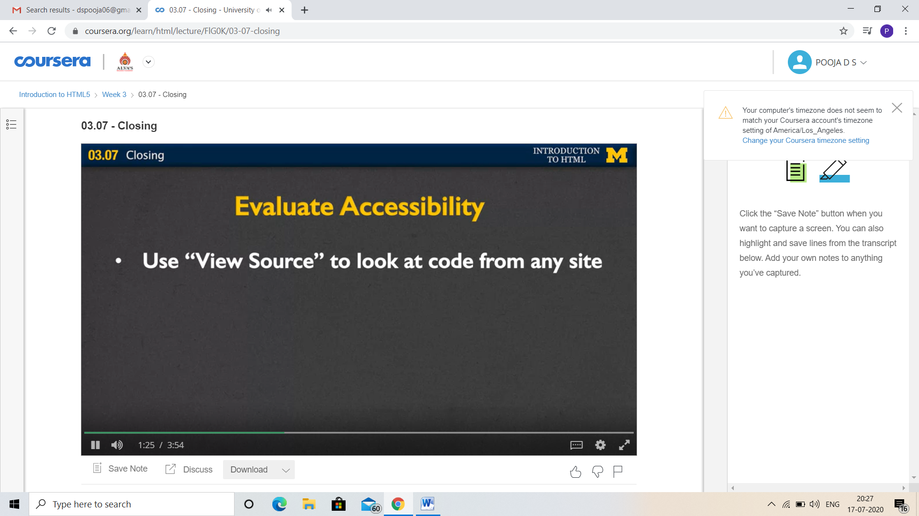

Online Training: Today I had attended the online training organized by CSE Department AIET. The training was on C programming language done by Prof. Megha Hegde. CSE Dept. After the session the quiz was conducted.